-- ========================= SAYLANI DATA ENGINEERING ==============================
-- HOMEWORK: CLASS 4 - MODIFYING DATA, DDL, DATA TYPES & CONSTRAINTS
-- Database: BikeStores Sample Database
-- Instructions: Write SQL statements to solve each problem below.
-- Answers will be provided in a separate file.
-- ================================================================================
NAME : NAHEED DEEDAR / ACADEMIC ID : 801925
-- ================================================================================
-- SECTION A: DATA TYPES & CONSTRAINTS (Conceptual Questions)
-- ================================================================================
-- Q1: What data type would you use for a product's weight (e.g., 2.5 kg)?
weight decimal(5,3) 12345.999
ANS : DECIMAL(5,3)
*******************************************************
-- Q2: In the sales.stores table, the zip_code is VARCHAR(5). Why not use INT?
ANS : Because ZIP/postal codes are:
identifiers, not numbers for calculation
We never:
- add ZIP codes
- subtract ZIP codes
- multiply ZIP codes
So don’t need numeric datatype
******************************************************

-- Q3: Look at sales.orders.order_status. The comment says 1=Pending,2=Processing,3=Rejected,4=Completed.
-- Is TINYINT a good choice? Why not use INT?
select * from [sales].[orders]
--yes, tinyint is a good choice
ANS : TINYINT is a very good choice for order_status. Because order statuses only contain small fixed values Like as Pending = 1, Processing = 2 , Rejected = 3, Completed = 4 .
**************************************************************
-- Q4: If you add a CHECK constraint that rating must be BETWEEN 1 AND 5, what happens if you try to INSERT rating = 0?
ANS : SQL Server will reject the INSERT.
0 is not between 1 and 5
The CHECK constraint validates data before insertion and enforce business rules / valid data
If we try to insert rating = 0, the INSERT operation will fail because it violates the CHECK constraint BETWEEN 1 AND 5.
**************************************************************
-- Q5: Why does sales.staffs have UNIQUE constraint on email but not on phone?
ANS : Database Design Rule :
UNIQUE = stable + reliable + truly identifying
Email fits unique identity
Phone does NOT can change / shared
Email has a UNIQUE constraint because it is a stable and reliable identifier for each staff member, commonly used for login and communication. Phone numbers are not unique because they can change, be shared among multiple people, or be entered in different formats, making them unreliable for enforcing uniqueness.
**************************************************************
-- ================================================================================
-- SECTION B: DDL (CREATE, ALTER, DROP)
-- ================================================================================

-- Q6: Create a new table called sales.loyalty_programs with the following columns:
-- - program_id (INT, auto-increment starting 1, PRIMARY KEY)
-- - program_name (VARCHAR(100), NOT NULL, UNIQUE)
-- - discount_rate (DECIMAL(3,2), NOT NULL, DEFAULT 0.05, CHECK between 0.00 and 0.50)
-- - start_date (DATE, NOT NULL, DEFAULT GETDATE())
-- - end_date (DATE, NULL)

CREATE TABLE sales.loyalty_programs (
program_id INT IDENTITY(1,1) NOT NULL,
program_name VARCHAR(100) NOT NULL UNIQUE,
discount_rate DECIMAL(3,2) NOT NULL
DEFAULT 0.05
CHECK (discount_rate BETWEEN 0.00 AND 0.50),
start_date DATE NOT NULL DEFAULT GETDATE(),
end_date DATE NOT NULL DEFAULT GETDATE()
);
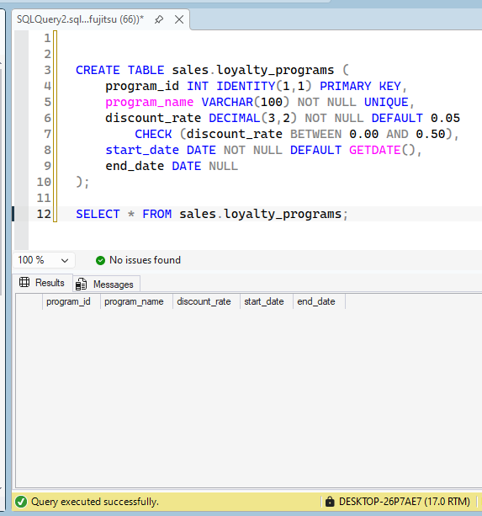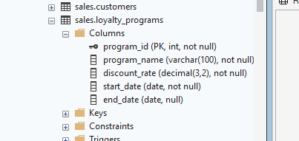

-- Q7: Add a new column 'loyalty_program_id' (INT, NULL) to the sales.customers table.
alter table sales.customers
add [loyalty_program_id] INT null;
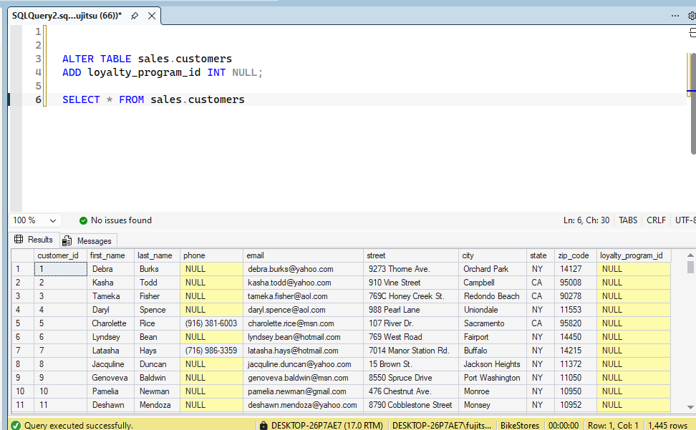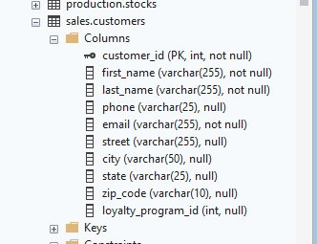

-- Q8: Add a FOREIGN KEY constraint to sales.customers.loyalty_program_id that references
-- sales.loyalty_programs.program_id.
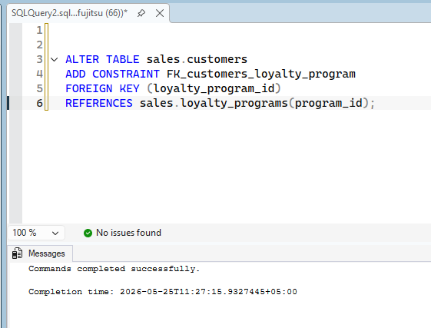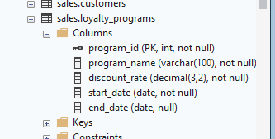

-- Q9: Change the data type of sales.customers.zip_code from VARCHAR(5) to VARCHAR(10).

ALTER TABLE sales.customers
ALTER COLUMN zip_code VARCHAR(10);
BEFORE :
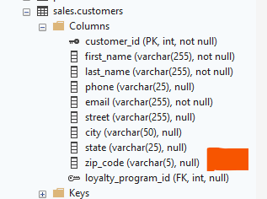
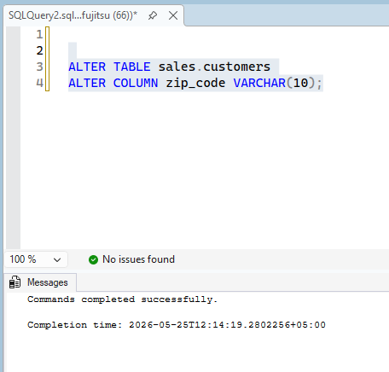
AFTER :
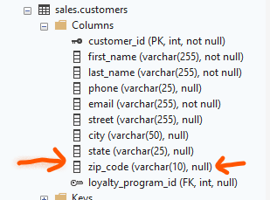

-- Q10: Drop the column 'birth_date' from sales.customers (first add it if it doesn't exist, then drop it).

alter table sales.customers
add birth_date date null;
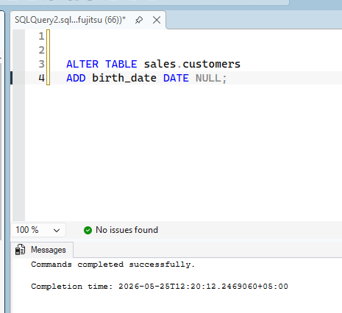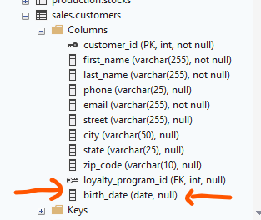

alter table sales.customers
drop column birth_date
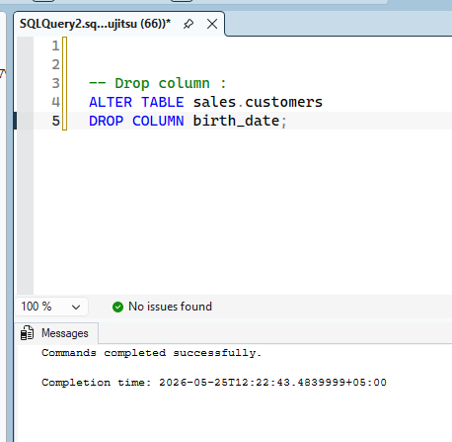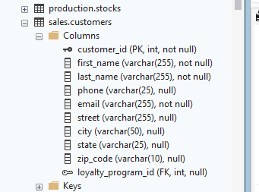

-- Q11: Create a new table production.product_reviews with appropriate columns and constraints:
-- - review_id (PK, auto-increment)
-- - product_id (FK to production.products)
-- - customer_id (FK to sales.customers)
-- - rating (TINYINT, 1-5)
-- - review_text (VARCHAR(1000))
-- - review_date (DATE, default today)
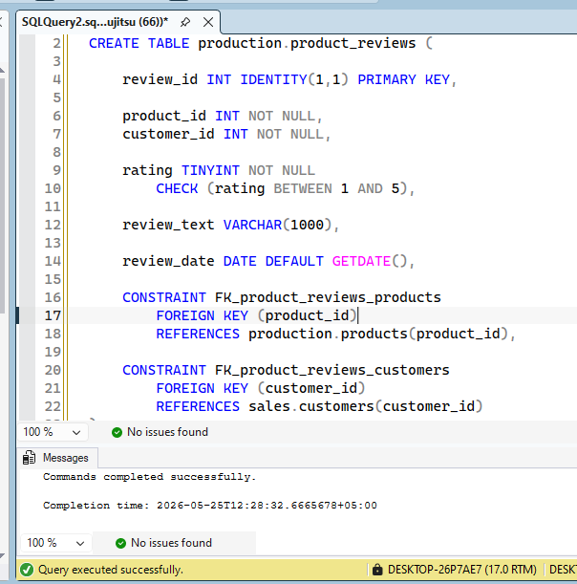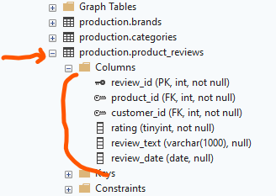

-- ================================================================================
-- SECTION C: INSERT STATEMENTS
-- ================================================================================

-- Q12: Insert a new brand called 'Santa Cruz' into production.brands.

SET IDENTITY_INSERT production.brands on;
INSERT INTO production.brands
(BRAND_ID, BRAND_NAME)
VALUES (9, 'Trek')
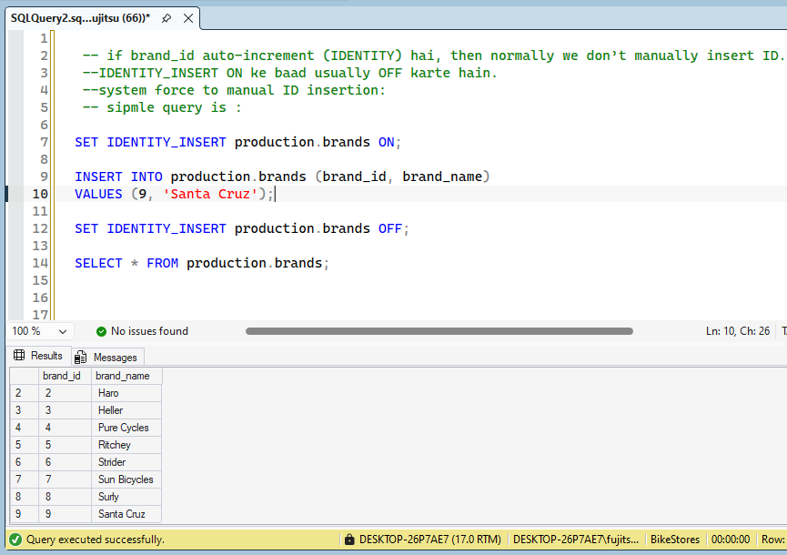

SELECT * FROM production.brands;
===================================================
-- Q13: Insert three new categories at once: 'Mountain', 'Road', 'Hybrid'.
SELECT * FROM production.categories;
INSERT INTO production.categories
(category_name)
VALUES ('Mountain'), ('Road'), ('Hybrid')
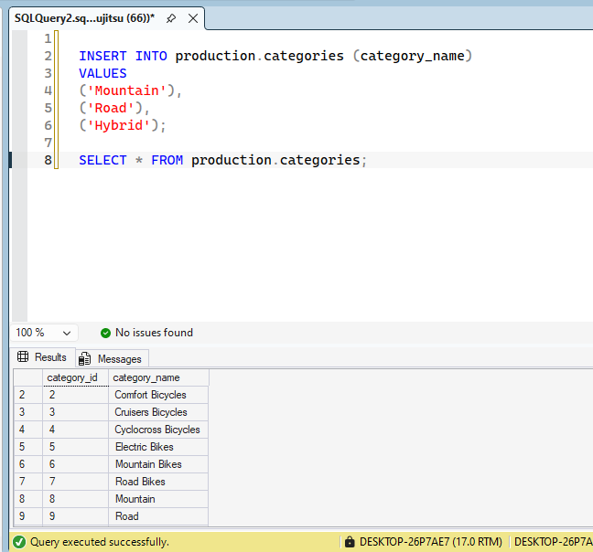

-- Q14: Insert a new product with the following details:
-- product_name = 'Santa Cruz Bronson'
-- brand_id = (the brand_id of 'Santa Cruz' from Q12)

-- category_id = (category_id of 'Mountain' from Q13)
-- model_year = 2025
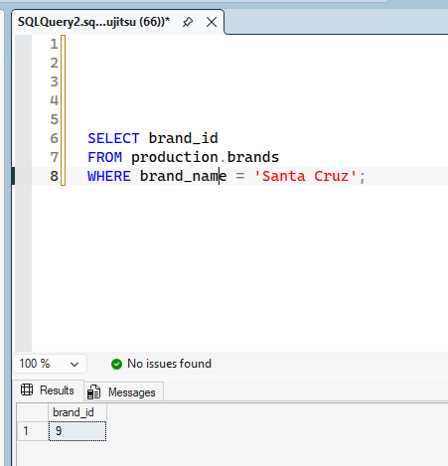
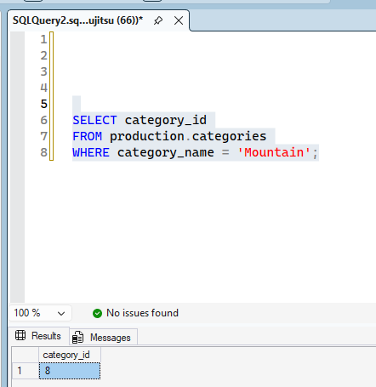
-- list_price = 4299.99
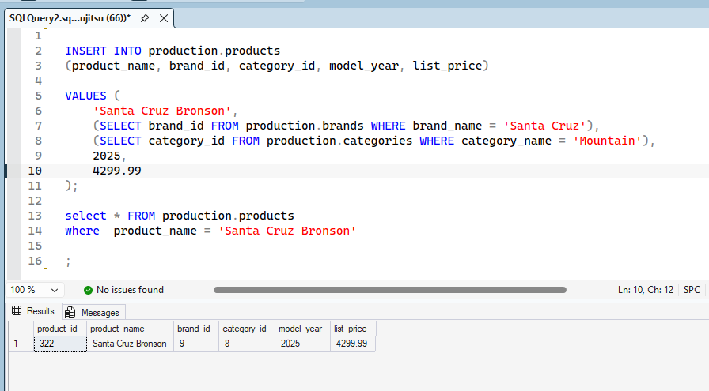

-- Q15: Copy all customers from California (state = 'CA') into a new table called sales.ca_customers_backup.
-- (Create the table first with the same structure as sales.customers)
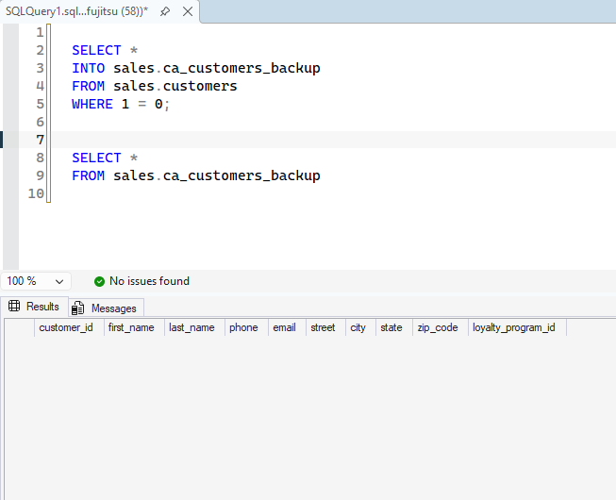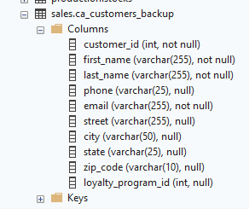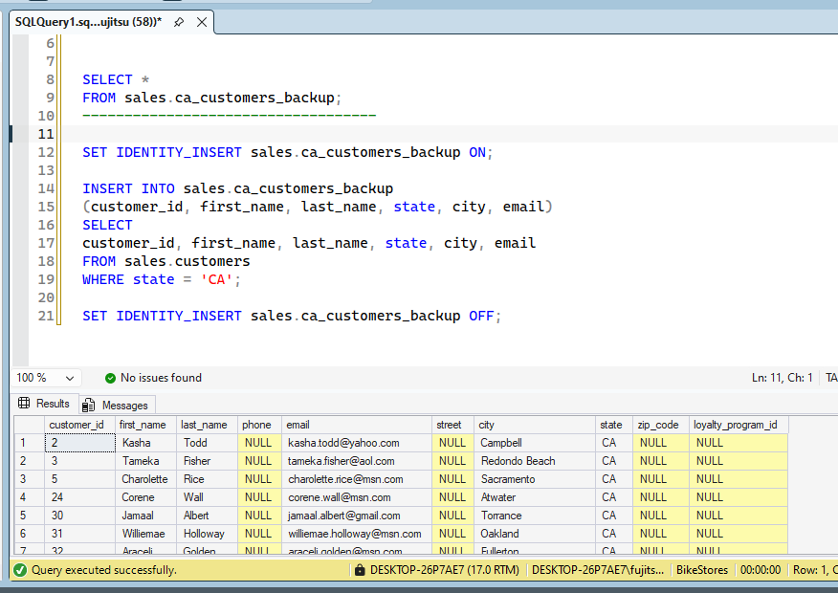

-- ================================================================================
-- SECTION D: UPDATE STATEMENTS
-- ================================================================================

-- Q16: Update the phone number of customer with customer_id = 10 to '(555) 123-4567'.
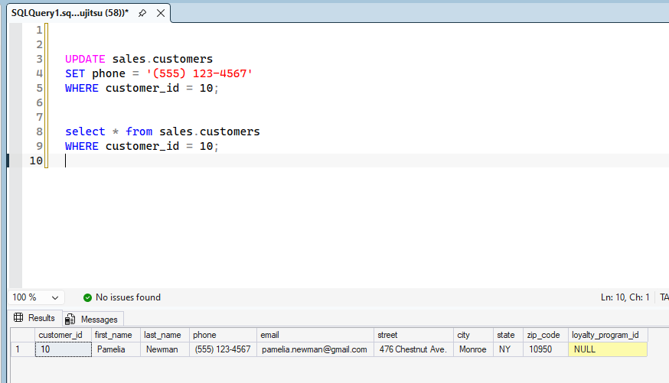

-- Q17: Increase the list price of all products in the 'Road' category by 8%.
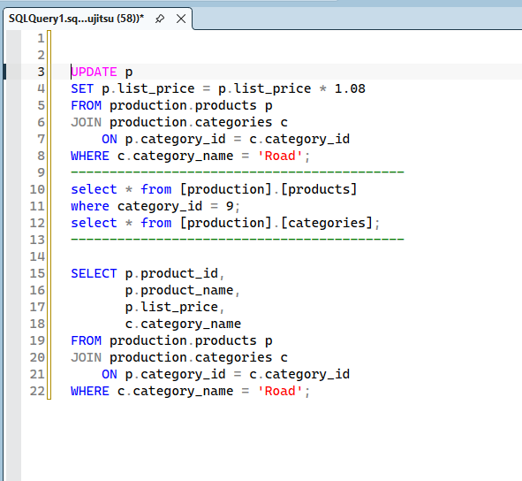

Technical Logic issue :
"The query executed successfully, but returned zero rows because the production.products table contains no active records associated with category_id = 9 (Road)."
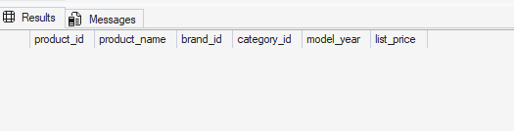

-- Q18: Mark all orders that have status = 4 (Completed) and shipped_date IS NULL
-- to set shipped_date = order_date + 3 days.
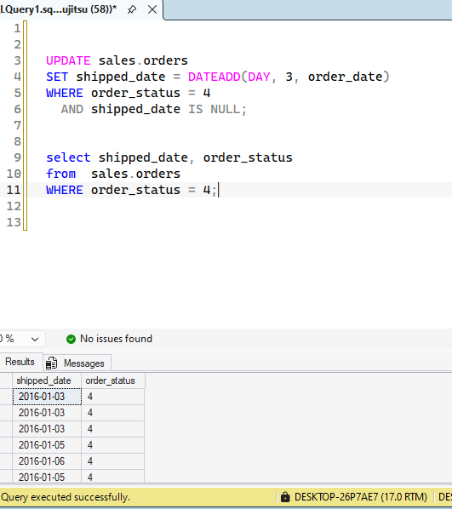

-- Q19: Set the manager_id of all staffs working at store_id = 1 to staff_id = 5
-- (assume staff_id 5 is the manager of that store).
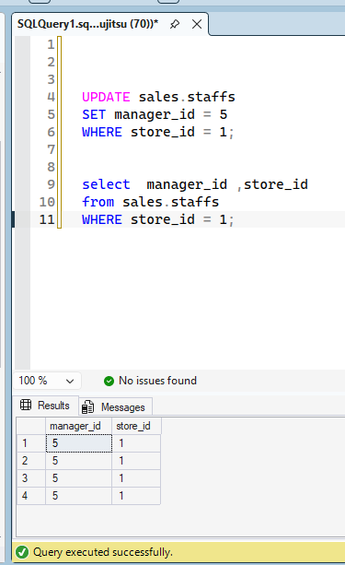

-- Q20: Update the discount for order_items where order_id = 100 and item_id = 2 to 0.15 (15%).
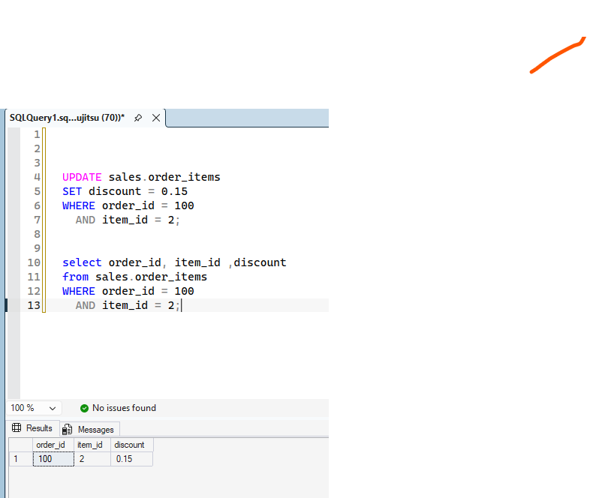

-- ================================================================================
-- SECTION E: DELETE STATEMENTS
-- ================================================================================

-- Q21: Delete the brand 'Santa Cruz' you inserted in Q12.
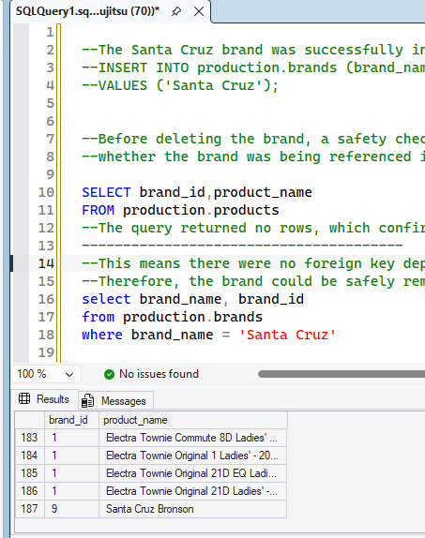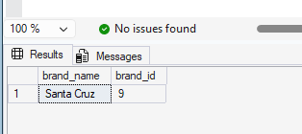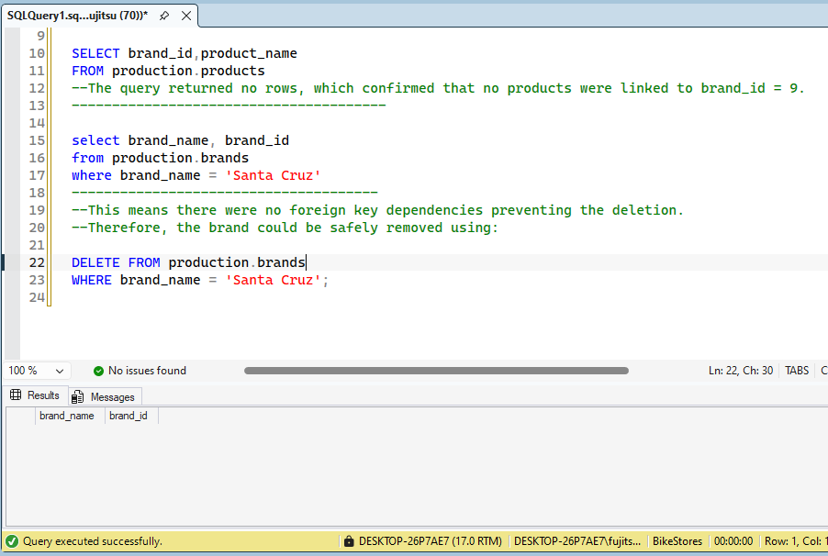
--This means there were no foreign key dependencies preventing the deletion.
--Therefore, the brand could be safely removed using:

-- Q22: Delete all order_items that have quantity = 0.
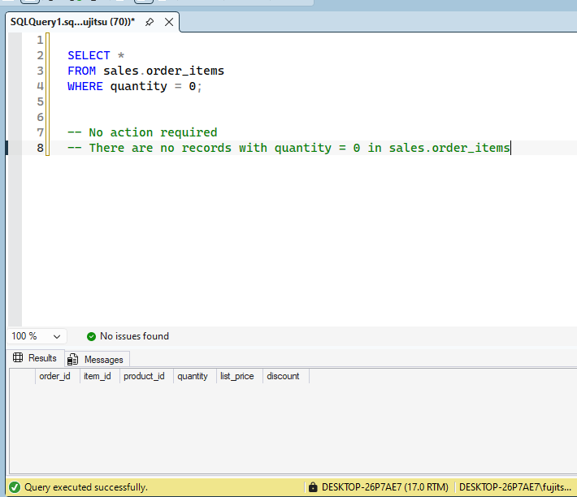

-- Q23: Delete all customers who have never placed an order (use subquery with NOT EXISTS).
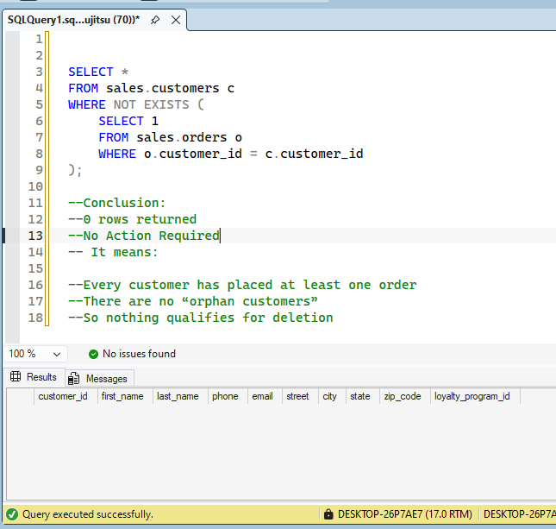
ANS : No customers were found without orders, so no deletion is necessary.

-- Q24: Delete all products that have list_price > 10000 and model_year < 2020.
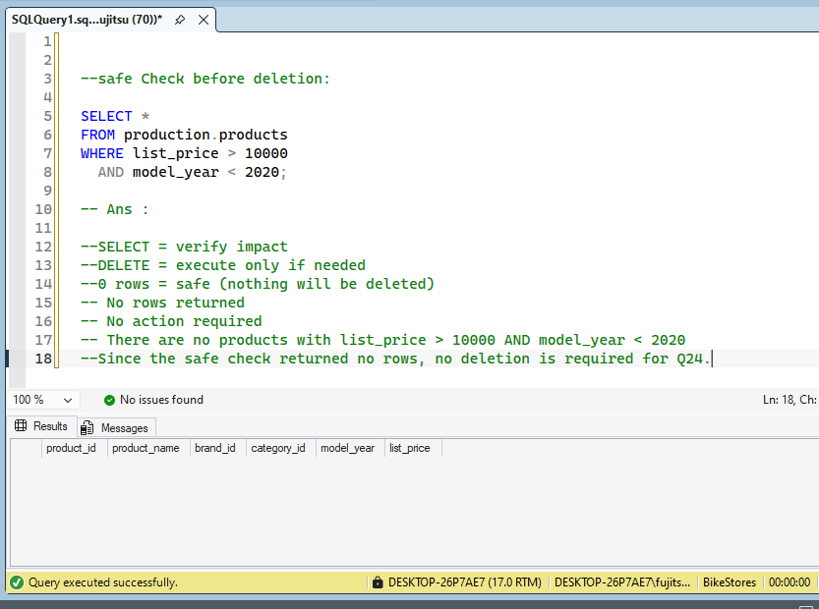

-- Q25: Delete the loyalty_programs table you created in Q6 (clean up).
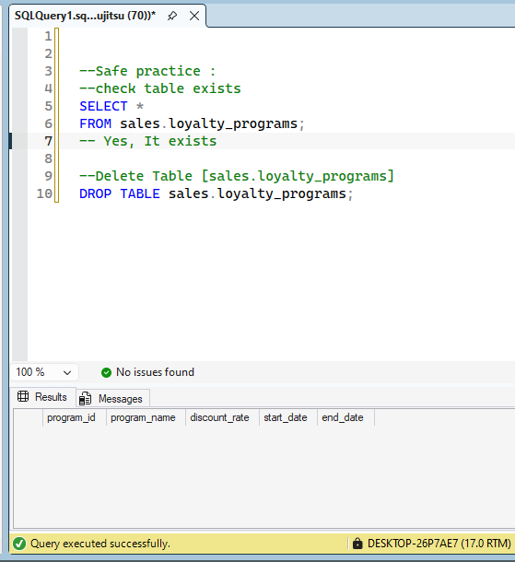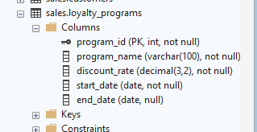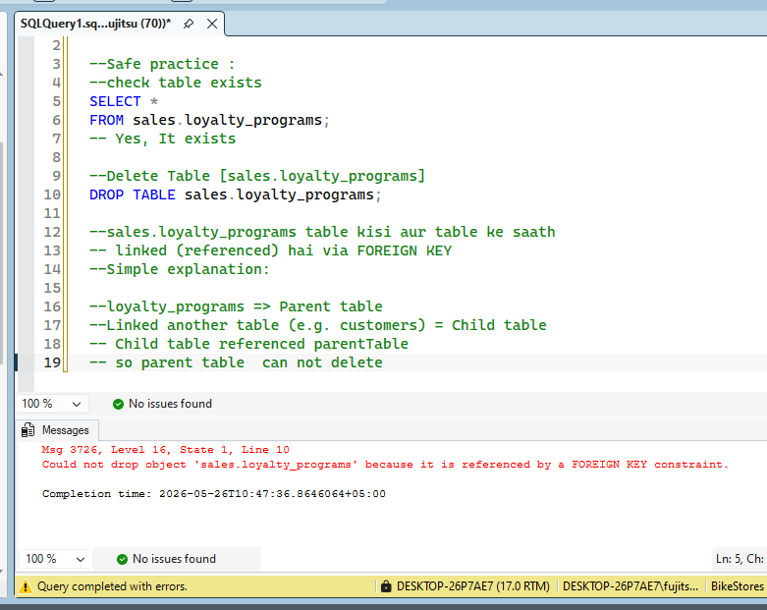

-- ================================================================================
-- SECTION F: COMBINED & CHALLENGE QUESTIONS
-- ================================================================================

-- Q26: Write a single transaction that:
-- 1. Creates a new store called 'Downtown LA'
-- 2. Adds 3 new staff members to that store
-- 3. Inserts 100 units of product_id = 1 into stocks for that store
-- (ROLLBACK if any step fails)
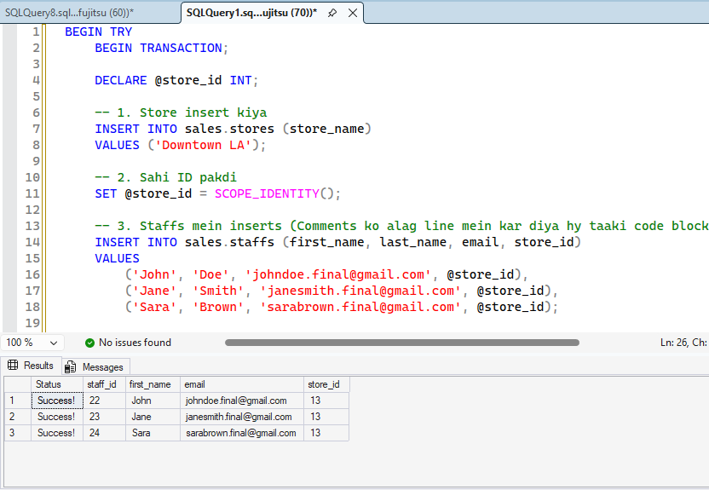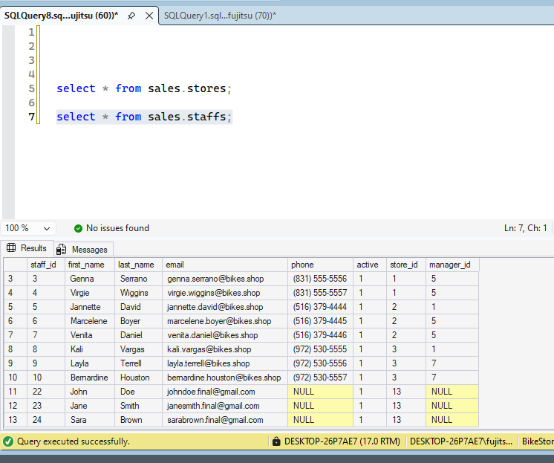
-- Q27: Change the schema of sales.order_items: add a new column 'tax_amount' DECIMAL(8,2) DEFAULT 0.00,
-- then update it to be (list_price * quantity * discount * 0.08) for all existing rows.
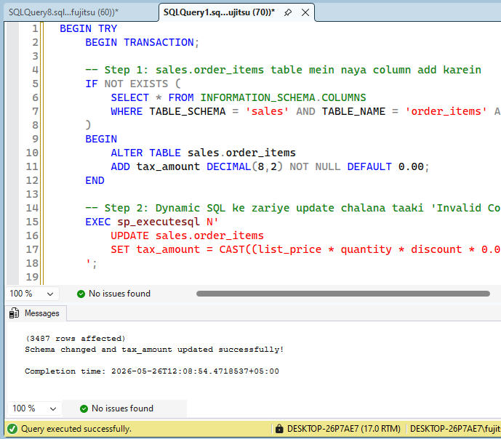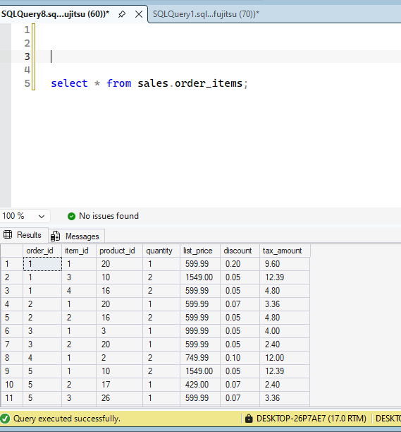

-- Q28: Identify and delete duplicate email addresses in sales.customers (keeping the smallest customer_id).
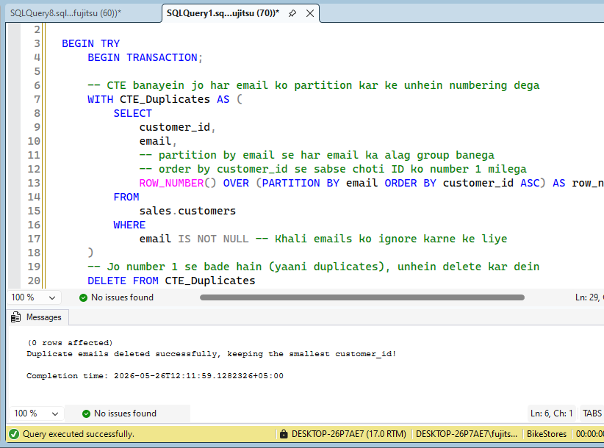
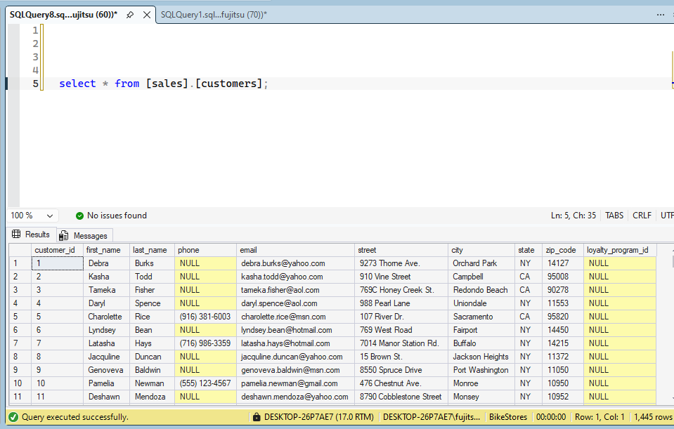

-- Q29: Archive all orders from year 2020 or older:
-- Insert them into a new table sales.orders_archive, then delete from sales.orders.
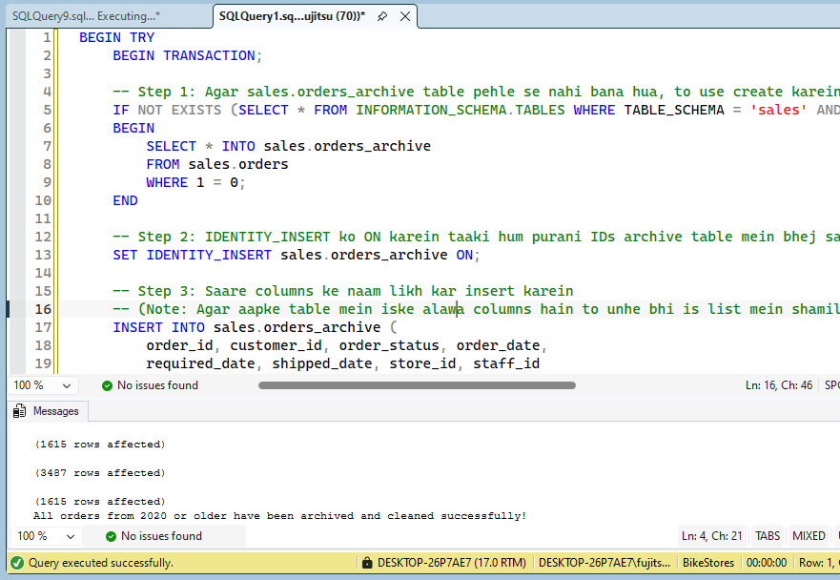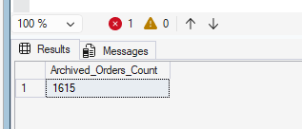
-- Q30: Add a CHECK constraint to production.products ensuring list_price >= 0 AND model_year BETWEEN 1900 AND YEAR(GETDATE())+1.
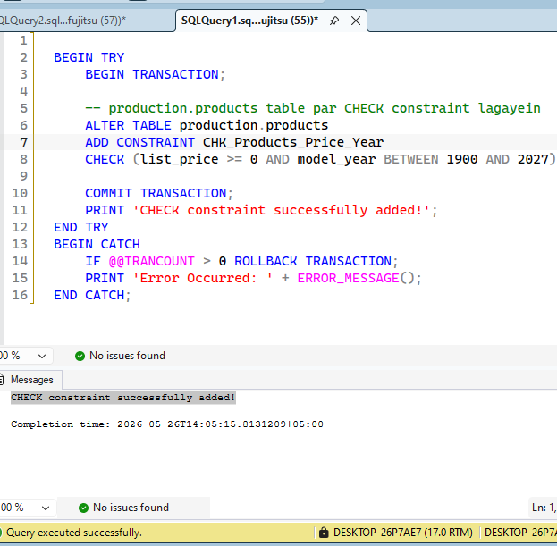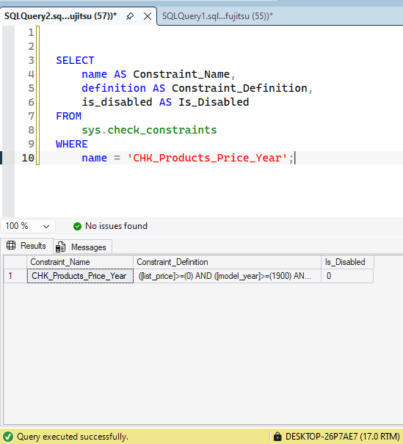

-- ================================================================================
-- END OF HOMEWORK QUESTIONS
-- ================================================================================

